**CONNECTING-JOBS**

Application which allotted different professionals to various companies.

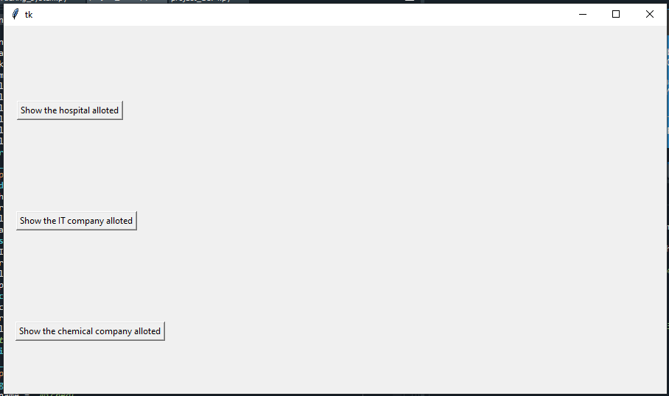

On click of “**Show the hospital allotted**” button, it will show the hospital allotted for “Micheal”.

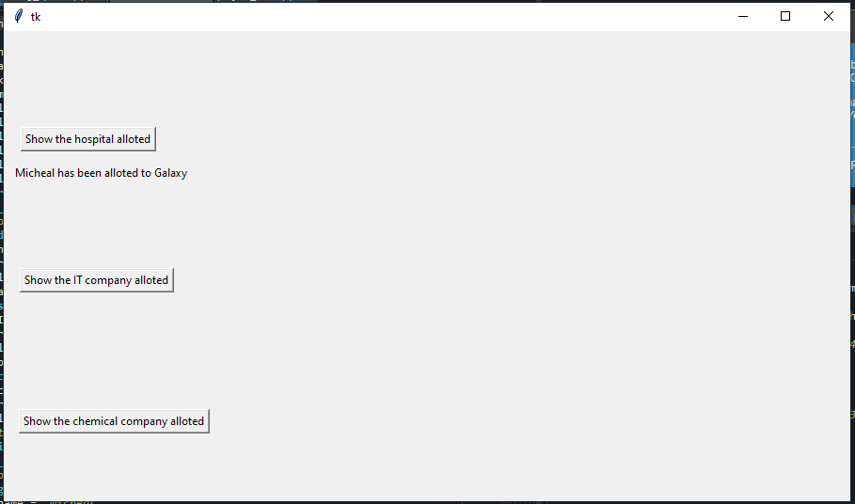

Similarly on click of "**Show the IT company allotted**" and "**Show the chemical company allotted**" button

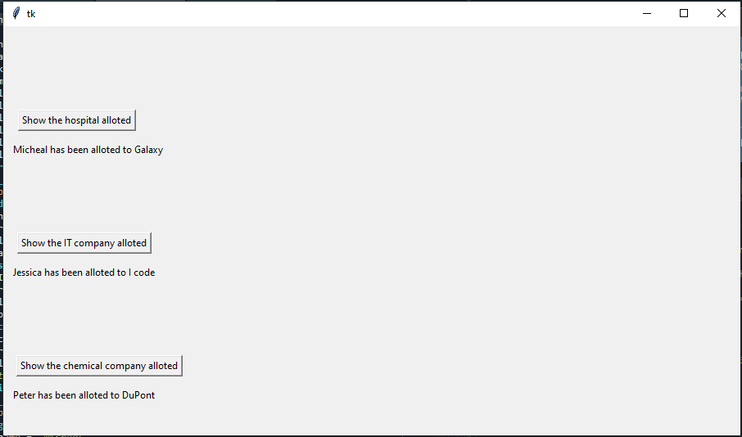

Similarly the names are displayed on the root window.